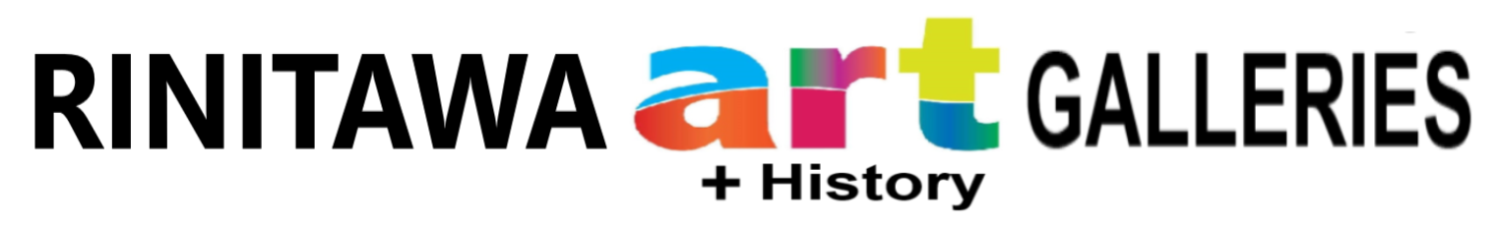
ENTRY FORM
TARARUA DISTRICT ANNUAL LINDAUER ART EXHIBITION
1 March 2023 - 27 March 2023

ENTRIES will be limited to 3 per person
Please use BLOCK LETTERS or type it. Keep your own copy.
Entries cost $15 per item and acceptance of a work is at the discretion of the organising committee.
Payment by by EFTPOS or prepaid by internet banking Lindauer Studio 02 0796 0023661 001

Artist name
Title Medium Price

1

2

3

(If the title doesn't fit into the space it is TOO long. A short title is a good title. Works must be labelled with this information on the tag with sufficient string so the Tag can hang and be able to be clearly seen AFTER the work is hung. This information will be put on a printed label)
Pieces to be hung should have D-links to enable them to be hung flat to the walls.
Exhibition organisers will oversee sales of works and deduct GST and 20% commission.
The number and type of entries are at the organisers’ discretion.

I have read and agree with the above conditions.

Name:__________________________________________

Email:___________________________________________

Address:__________________________________________

Phone no:_________________________________________

Bank ACC Name:_______________________________Bank Acc No ___ _______ _____________ ___

This form must be provided, with payment, BY 3p MON 27 FEBRUARY, or by 11a TUE 28 FEBRUARY.
delivered to RINITAWA ART+History GALLERIES, cnr Vogel and Grey St, Woodville.

Enquiries: please phone 022 0973 662 or 027 974 9491

